[Maximizing the “value” in value networks and value-based payment | McKinsey](https://www.mckinsey.com/industries/healthcare/our-insights/maximizing-the-value-in-value-networks-and-value-based-payment)

 creating more limited provider networks to shift patient volume to more cost-efficient providers and

In addition, they have embraced value-based payment as a way to reward providers for delivering high-quality care at lower cost, improving performance over time, or both.

Finding ways to raise the stakes (both positive and negative) for providers to adopt and perform under value-based payment models is therefore likely to be essential to transforming care delivery.

 even an imperative—exists to reconsider the design and implementation of both value networks and value-based payment.

Priority checklist

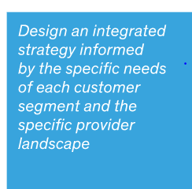

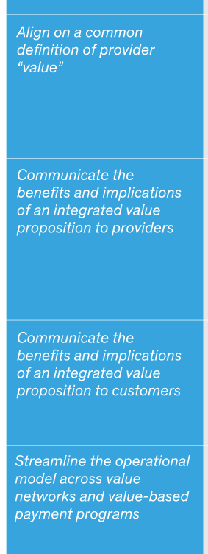

**Barriers to maximizing potential**

Many payers have implemented value networks and value-based payment as independent strategies.

In fact, many payers (and provider executives) perceive value networks and value-based payment as being at odds with each other:

they often **conceive of narrowing networks as a quick fix to drive down costs by weeding out high-priced providers**, and **value-based payment as a long-term partnership to enable performance improvement in a purely win–win way**. We believe that this understanding of the two strategies has deterred payers from integrating them and led to the suboptimal performance of both.

[regulatory-options-for-provider-network-adequacy.pdf (brookings.edu)](https://www.brookings.edu/wp-content/uploads/2017/09/regulatory-options-for-provider-network-adequacy.pdf)

As health insurers become more price-competitive, they more often are **selling health plans that cover fewer hospitals, and many fewer physicians**, **in an effort to provide greater consumer value.**

This narrowing of provider networks is an indication that **recent reforms are making insurance markets more competitive**, but narrowing networks also raise concern about consumer protection.

[bhi_pnoa_final.indd (bluehealthintelligence.com)](https://bluehealthintelligence.com/wp-content/uploads/2020/01/SS_ProviderNetworkOptimization_0120.pdf)

PROVIDER NETWORK OPTIMIZATION

More and more health plans and employers are turning to **high-performing narrow networks** to **improve healthcare quality**. In fact, according to a recent National Business Group on Health® survey, more than 62% of all employers have contracted, or plan to contract, with Centers of Excellence (COEs) for their employees’ healthcare benefits. Blue Health Intelligence’s® (BHI®) **provider network optimization analytics** ensure that health plan leaders can identify the **lowest-cost, highest-quality provider networks for their members,** employees, and beneficiaries

Our consultants objectively **evaluate costs and quality across facilities and determine if member-provider relationships will be improved or harmed** if providers are added or excluded from a network.

BHI’s analysis also reveals **where network configuration and design changes could be made to improve performance**

Using Data-driven Network Insights for Business Decisions Our unique access to the most comprehensive healthcare database in the U.S.* allows plan administrators to run a multitude of different **“if-then” analyses to help them make informed, data-driven decisions about their provider networks**

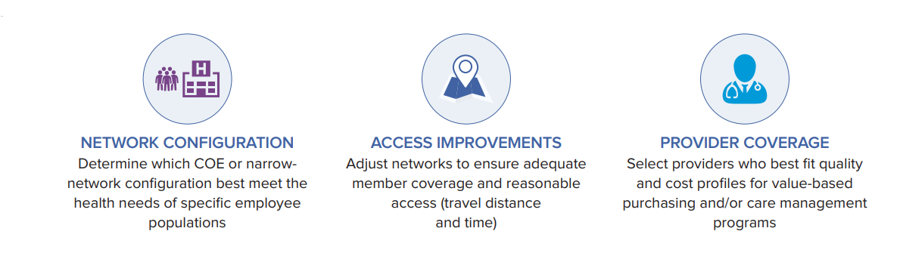

OUR PROVEN NETWORK-OPTIMIZATION ANALYTIC CAPABILITIES

Insurance companies has their provider network

How to optimize?

How to choose hospital, doctors ?

Cost should be lowest

Good services/ quality of care / improve health outcomes

Members should satisfy

1. We need to analyze top performing doctors and worst performing doctors by using analytics to retain or remove(identify under performing doctors)- to improve
2. Which disease which my patients gets(age mor than 40)- we need those kind of hospitals or doctors needed by using cohots-
3. Distance: accessibility –
4. Demographics- to know health needs
5. Reference : general physician knows patient well suggest which specialist req for the patients (doctor knows), past cases which this doctor has treated , they may not know doctors inside the network
6. Ranking of doctors

-Eliminated non performing doctors , (cost of care decreases)- less premium

To improve referral network

•   
Leverage competitive intelligence to strengthen position

• Standardize and cleanup provider data for simplified search

• Measure network performance against accessibility, cost and quality standards

• Deliver dynamic, functionally rich provider search solutions

• Understand the financial performance of your network

[Faster Network Builds - Zelis](https://www.zelis.com/solutions/network-solutions/network-performance/)

Advance your network build and optimization efforts.

Zelis Network Builder and Optimizer combines your in-house CRM and provider metrics with our own data around access, adequacy, and competitive performance to address gaps and prevent over contracting. Giving you the data to have confidence in your network.

Plus, with Zelis Network Build Protection, you’ll have a back-up network for your members to access while you finalize contracts and other details.

#### **Network Data**

Leverage both in-house and Zelis proprietary data to meet requirements and uncover key insights about key performance metrics.

2.

#### **Network Data**

Leverage both in-house and Zelis proprietary data to meet requirements and uncover key insights about key performance metrics.

#### **Virtual Network Builder**

Create virtual networks and test them against key access and adequacy requirements and adjust before going to market.

#### **Network Build Protection**

Avoid the stress of tight deadlines, last-minute credentialing and contracting hiccups with backup, ready-to-go network options that ensure you’re covered until your network build is complete.

#### **Adequacy**

Measure access and minimum provider ratios for individual physicians and facilities, both in your own and competitors’ networks.

#### **Cost Impact**

Project costs and estimate network savings, based on member utilization before going to market, to drive more informed decisions about provider selection.

#### **Contracting**

Custom, employer-specific contracting with Zelis enables plans to build and offer networks with the provider coverage they need to deliver optimal results and win business.

#### **Credentialing**

Proactively move the process earlier in the network build to eliminate delays. Don’t let credentialing be an afterthought.

# **Network Strategy, Maintenance and Sales**

## **See a 360-degree view of your provider network.**

## Develop, manage and sell smarter and more adaptable networks.

There’s no such thing as a one-size-fits all, set-it-and-forget-it network anymore. Your provider network needs to adapt to both competitive and regulatory forces, and Zelis is here to help.

Our Network360® Analytics Suite enables you see both the big picture and the finer details. You’ll get a sense of how you compare to your competitors in terms of provider participation, access and coverage. You’ll be able to spot gaps – and opportunities to fill them.

Zelis will help you turn the data in Network360® into action, shaping your network strategy and building a modern, flexible network that meets your members’ most important needs.



#### **Understand Your Position**

See how your network compares to competitors based on specialty, geography, and market segment in order to retain and win business.

#### **Recruit Providers**

Generate lists of providers based on network participation, specialty, geography, and market segment to maintain network competitiveness and compliance through recruitment.

#### **Disruption Analysis with TrueDisruptionSM**

Measure your network’s disruption with our enhanced approach that adds competitive provider data to traditional analyses, to highlight where you win over the competition.

#### **Custom Network Insights**

Connect with consultants for custom network evaluation reports and dashboards covering service area, market segment, accuracy, historical trends and more.

## Provider Decision Support in action

* **Maintain the integrity of provider network data**
* **Build single- and multi-carrier provider search solutions**
* **Identify and correct discrepancies in network information**
* **Standardize provider information according to internal business rules**
* **Provide members with the most reliable provider search tools**
* **Offer scalable solutions to unique needs to large enterprise implementations**

# **Reference-Based Pricing for Network Replacement**

## Stabilize claims costs and improve provider accountability.

Traditional healthcare costs continue to run rampant with provider pricing variability. **Payers need new strategies to stabilize claims costs and improve provider accountability around rising and variable fees.**

Zelis’ **Reference Based Pricing (RBP) Network Replacement** sets **maximum reimbursement amounts** using pre-defined prices, providing a controlled savings model that gives members more control over their healthcare provider choices.



#### **Customizable Solution**

Payers need to meet a variety of unique employer needs, so we’ve designed a variety of network replacement options to meet them. Zelis’ RBP Network Replacement solution includes out-of-network savings, full network replacement, narrow networks, and custom network build options.

#### **Comprehensive Support**

Zelis support helps mitigate the risk of balance billing and improve member satisfaction. Clients can expand their RBP implementation beyond the core components with a range of options designed to advocate for members, improve transparency, manage risk and drive savings.

1. Helping healthcare providers transform performance in labor, external spend, clinical operations, and capital through our unique combination of deep industry experience, advanced analytics, and cutting-edge tools

Health plans currently get snippets of provider data from claims, provider group rosters, and the contracting and credentialing processes.

To address these data weaknesses, health plans should corroborate information across different data sources using data management solutions. This presents the critical need to adopt a multi-faceted approach that utilizes claims analytics, machine learning, and additional industry touch points to provide context and validation for those data sources

The challenge is ensuring this information is validated and accurate. It's time for the healthcare industry to have a single hub that leverages all of the cross-industry touchpoints with providers across the continuum of care to help identify anomalies in the data and drive greater accuracy.

## Provider Data Enhancements gives your organization better results with correct, current and comprehensive healthcare provider data and auditing capabilities

Gathered, enhanced data of providers from claims, provider group rosters, and the contracting and credentialing processes for better results

We have consolidated and enhanced vendor data from claims, vendor lists, and contracting and credentialing processes for better results.